
North South University
Department of Electrical & Computer Engineering

Lab Report

Experiment No: | 5
Experiment Title: | Design of a Register File

Course Code: | CSE332L
Course Name: | Computer Organization & Architecture Lab

Name & ID: | Md. Rifat Ahmed ~ 1931725042

Date of Experiment: | 30/11/2021
Date of Submission: | 30/11/2021

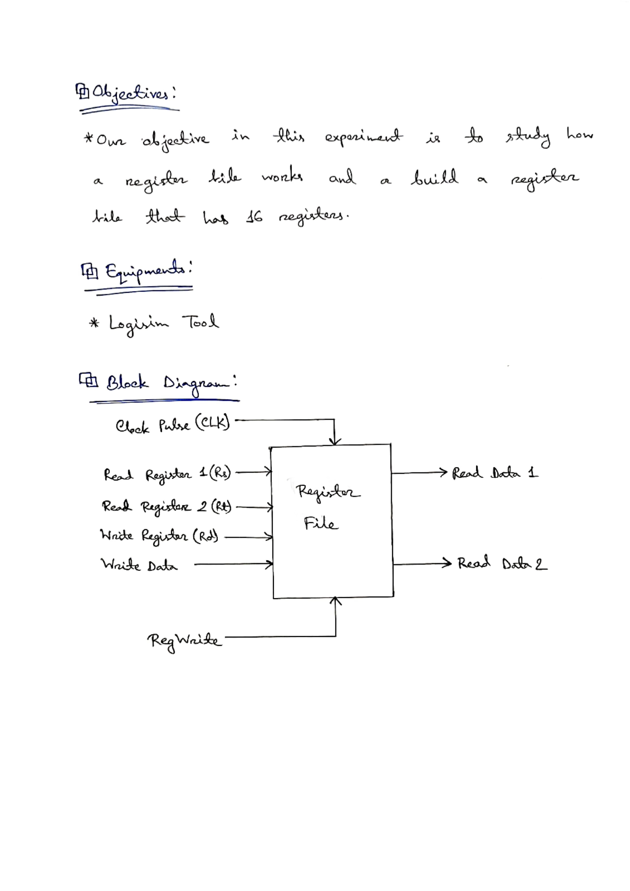
Table:

We’ll be building a Register file for the 16-bit ISA with following fields where the formats of the instruction are:

R-type:
OP (4-bit) | Rs (4-bit) | Rt (4-bit) | Rd (4-bit)

I-type:
OP (4-bit) | Rs (4-bit) | Rt (4-bit) | Immediate (4-bit)

J-type:
OP (4-bit) | Target (12-bit)

Circuit Diagram:

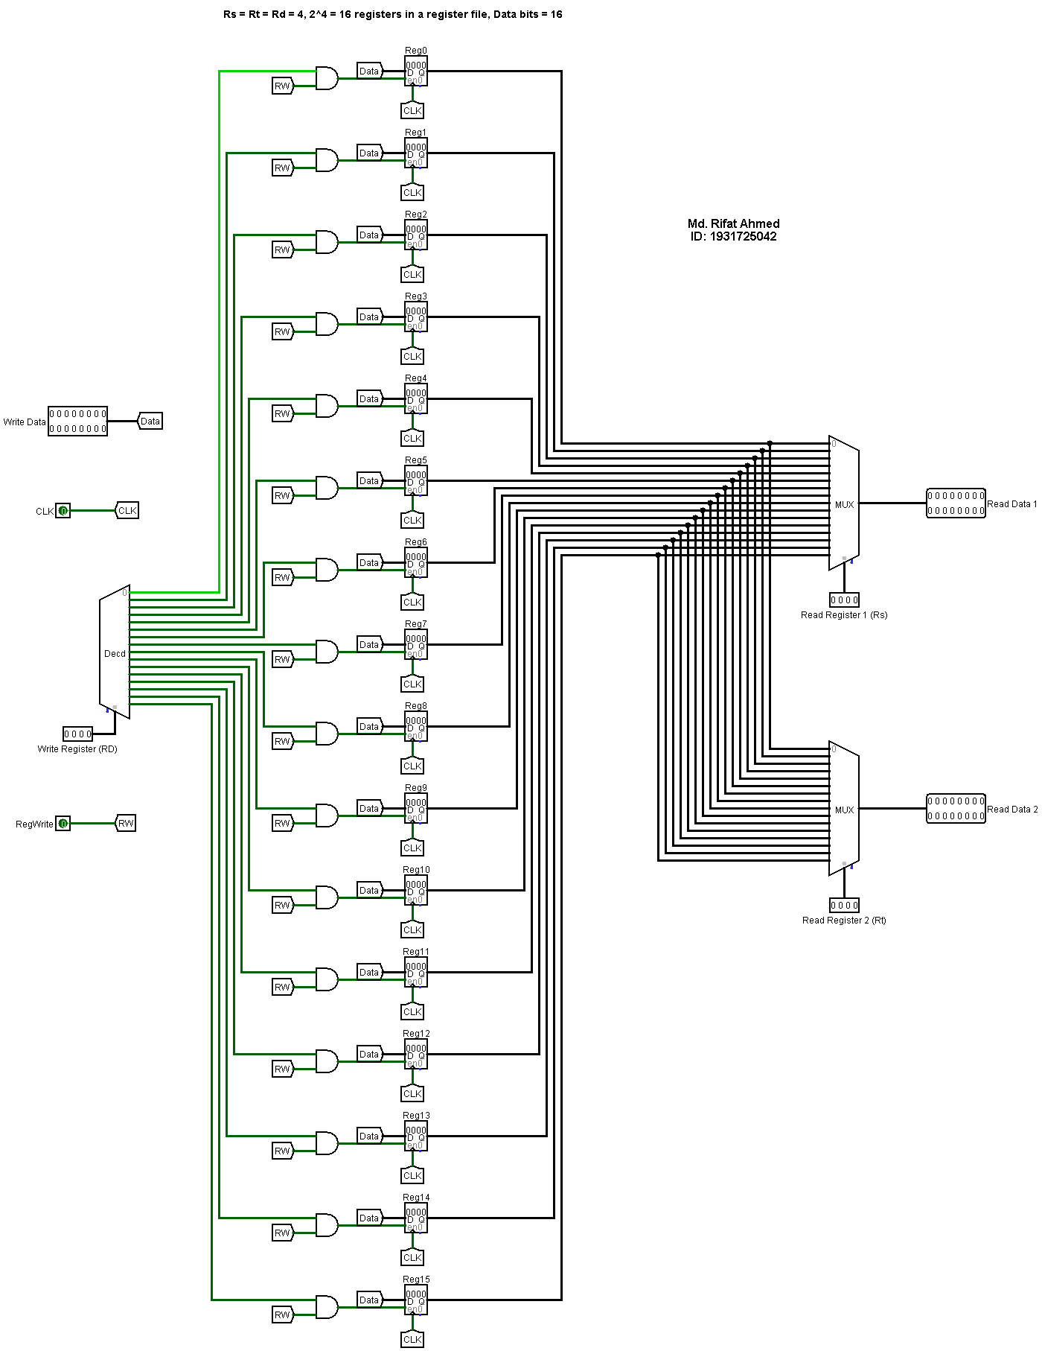
Figure – 2: Circuit diagram of a 4-bit by 4-bit Binary Multiplication Unit
